Contestant Number: _________________
Time: __________
Rank: __________



NETWORK ADMINISTRATION

USING CISCO®

(315)

STATE – 2020

TOTAL POINTS ___________ (500 points)

Failure to adhere to any of the following rules will result in disqualification:
- Contestant must hand in this test booklet and all printouts. Failure to do so will result in disqualification.
- No equipment, supplies, or materials other than those specified for this event are allowed in the testing area. No previous BPA tests and/or sample tests or facsimile (handwritten, photocopied, or keyed) are allowed in the testing area.
- Electronic devices will be monitored according to ACT standards.

No more than sixty (60) minutes testing time

Property of Business Professionals of America.
May be reproduced only for use in the Business Professionals of America
Workplace Skills Assessment Program competition.

MULTIPLE CHOICE
Identify the letter of the choice that best completes the statement or answers the question.

- A network technician is configuring port security on a LAN switch interface. The security policy requires host MAC addresses to be learned dynamically, stored in the address table, and saved to the switch running configuration. Which command does the technician need to add to the following configuration to implement this policy?
Switch(config)#interface fa0/1
Switch(config-if)#switchport mode access
Switch(config-if)#switchport port-security
  - Switch(config-if)#switchport port-security maximum 40
  - Switch(config-if)#switchport port-security mac-address
  - Switch(config-if)#switchport port-security mac-address sticky
  - Switch(config-if)#switchport port-security mac-address 000B.FCFF.E880

- On which switch interface would an administrator configure an IP address so that the switch can be managed remotely?
  - FastEthernet0/1
  - VLAN 1
  - vty 0
  - console 0

- Refer to the exhibit.
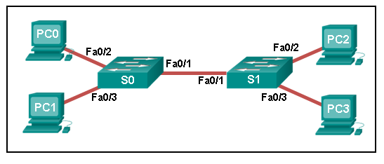
A ping to PC3 is issued from PC0, PC1, and PC2 in this exact order. Which MAC addresses will be contained in the S1 MAC address table that is associated with the Fa0/1 port?
  - just PC0 and PC1 MAC addresses
  - just the PC0 MAC address
  - PC0, PC1, and PC2 MAC addresses
  - just the PC1 MAC address

- Which feature on a Cisco router permits the forwarding of traffic for which there is no specific router?
  - next-hop
  - gateway of last resort
  - route source
  - outgoing interface

- Refer to the exhibit.
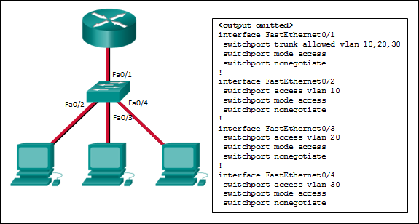
Inter-VLAN communication between VLAN 10, VLAN 20, and VLAN 30 is not successful. What is the problem?
  - The access interfaces do not have IP addresses and each should be configured with an IP address.
  - The switch interface FastEthernet0/1 is configured as an access interface and should be configured as a trunk interface.
  - The switch interface FastEthernet0/1 is configured to not negotiate and should be configured to negotiate.
  - The switch interfaces FastEthernet0/2, FastEthernet0/3, and FastEthernet0/4 are configured to not negotiate and should be configured to negotiate.

- How will a router handle static routing differently if Cisco Express Forwarding is disabled?
  - It will not perform recursive lookups.
  - Serial point-to-point interfaces will require fully specified static routes to avoid routing inconsistencies
  - Ethernet multi-access interfaces will require fully specified static routes to avoid routing inconsistencies
  - Static routes that use an exit interface will be unnecessary

- Refer to the exhibit.
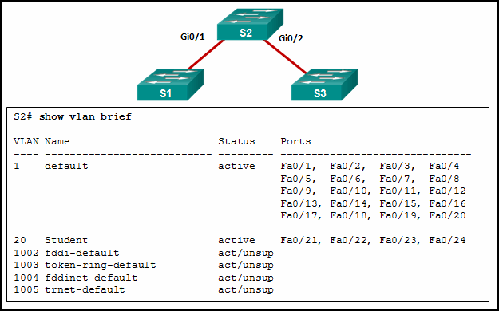
A network administrator is reviewing port and VLAN assignments on switch S2 and notices that interfaces Gi0/1 and Gi0/2 are not included in the output. Why would the interfaces be missing from the output?
  - There is a native VLAN mismatch between the switches.
  - There is no media connected to the interfaces.
  - They are administratively shut down.
  - They are configured as trunk interfaces.

- Which address type is not supported in Ipv6?
  - private
  - multicast
  - unicast
  - broadcast

- Refer to the exhibit.
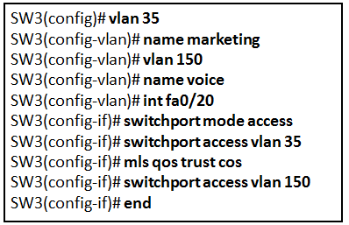
A technician is programming switch SW3 to manage voice and data traffic through port Fa0/20. What, if anything, is wrong with the configuration?
  - There is nothing wrong with the configuration
  - Interface Fa0/20 can only have one VLAN assigned
  - The mls qos trust cos command should reference VLAN 35
  - The command used to assign the voice VLAN to the switch port is incorrect

- How many /30 subnets can be created from one /27 subnet?
  - 2
  - 4
  - 6
  - 8

- A network administrator is using the router-on-a-stick model to configure a switch and a router for inter-VLAN routing. What configuration should be made on the switch port that connects to the router?
  - Configure the port as an access port and a member of VLAN1.
  - Configure the port as an 802.1q trunk port
  - Configure the port as a trunk port and assign it to VLAN1.
  - Configure it as a trunk port and allow only untagged traffic.

- A network administrator is designing an Ipv4 addressing scheme and requires these subnets.
1 subnet of 100 hosts
2 subnets of 80 hosts
2 subnets of 30 hosts
4 subnets of 20 hosts
Which combination of subnets and masks will provide the best addressing plan for these requirements?
  - 9 subnets of 126 hosts with a 255.255.255.128 mask
  - 3 subnets of 126 hosts with a 255.255.255.128 mask
6 subnets of 30 hosts with a 255.255.255.240 mask
  - 3 subnets of 126 hosts with a 255.255.255.192 mask
6 subnets of 30 hosts with a 255.255.255.240 mask
  - 1 subnet of 126 hosts with a 255.255.255.192 mask
2 subnets of 80 hosts with a 255.255.255.224 mask
6 subnets of 30 hosts with a 255.255.255.240 mask

- A network administrator has allocated the Ipv4 10.10.240.0/20 block of addresses for a LAN. Two devices on two different, but contiguous, subnets on the LAN have been assigned the addresses 10.10.247.1/21 and 10.10.248.10/24, respectively. The administrator has to create a third subnet from the remaining address range. To optimize the use of this address space, the new subnet will follow on directly from the existing subnets. What is the first available host address in the next available subnet?
  - 10.10.248.17
  - 10.10.249.1
  - 10.10.250.1
  - 10.10.255.17

- When creating an Ipv6 static route, when must a next-hop Ipv6 address and an exit interface both be specified?
  - when CEF is enabled
  - when the static route is a default route
  - when the next hop is a link-local address
  - when the exit interface is a point-to-point interface

- Which statement describes the Cisco License Manager?
  - It is a free, standalone software application for deploying Cisco software licenses across the network.
  - It is a web-based portal for getting and registering individual software licenses.
  - It is a centralized TFTP server that enables control of the number and revision level of Cisco IOS images.
  - It is an organized collection of processes and components used to activate Cisco IOS software feature sets by obtaining and validating Cisco software licenses.

- After a license has been purchased and installed, what is the next step that is required before it is activated?
  - Reboot the router
  - Copy the running configuration to NVRAM.
  - Copy the running configuration to flash.
  - Issue the license boot module technology-package command.
- Refer to the exhibit.
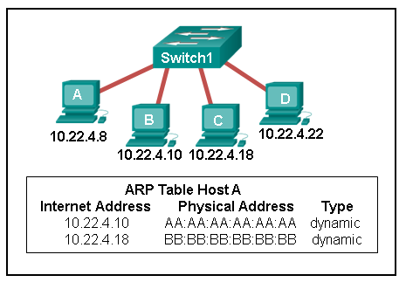
A switch with a default configuration connects four hosts. The ARP table for host A is shown. What happens when host A wants to send an IP packet to host D?
  - Host A sends an ARP request to the MAC address of host D. Host D responds with its IP address.
  - Host D sends an ARP request to host A. Host A responds with its MAC address.
  - Host A sends out the packet to the switch. The switch adds the MAC address for host D to the frame and forwards it to the network.
  - Host A sends out a broadcast of FF:FF:FF:FF:FF:FF. Every other host connected to the switch receives the broadcast and host D responds with its MAC address.

- Refer to the exhibit.
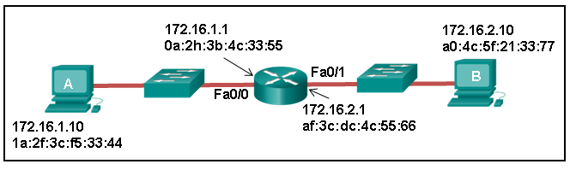
Host A sends a data packet to host B. What will be the addressing information of the data packet when it reaches host B?

  - 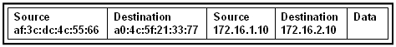

  - 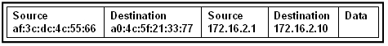

  - 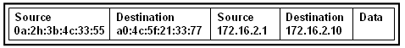

  - 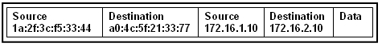

- A user sends an HTTP request to a web server on a remote network. During encapsulation for this request, what information is added to the address field of a frame to indicate the destination?
  - the MAC address of the destination host
  - the network domain of the destination host
  - the MAC address of the default gateway
  - the IP address of the default gateway

- An administrator who is troubleshooting connectivity issues on a switch notices that a switch port configured for port security is in the err-disabled state. After verifying the cause of the violation, how should the administrator re-enable the port without disrupting network operation?
  - Reboot the switch
  - Issue the shutdown command followed by the no shutdown command on the interface.
  - Issue the no switchport port-security command, then re-enable port security.
  - Issue the no switchport port-security violation shutdown command on the interface.
- Refer to the exhibit.
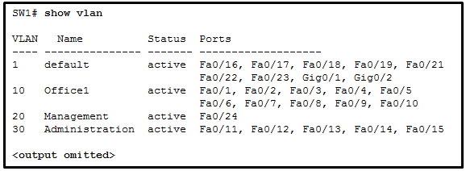
A network technician issues the command show vlan to verify the VLAN configuration. Based on the output, which port should be assigned with native VLAN?
  - Gig0/1
  - Fa0/12
  - Fa0/20
  - Fa0/24

- A network engineer is troubleshooting connectivity issues among interconnected Cisco routers and switches. Which command should the engineer use to find the IP address information, host name, and IOS version of neighboring network devices?
  - show version
  - show ip route
  - show interfaces
  - show cdp neighbors detail

- Refer to the exhibit.
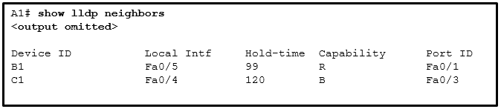
A network administrator issues the show lldp neighbors command to display information about neighboring devices. What can be determined based on the information?
  - Device B1 is a WLAN access point
  - Device C1 is a switch
  - Device A1 is connected to the port Fa0/5 on device B1
  - Device C1 is connected to device B1 through the port Fa0/3.

- What type of installation is needed to view syslog messages?
  - A syslog server must be installed on a workstation
  - A syslog client must be installed on a workstation
  - A syslog server must be installed on a router.
  - Because any network equipment can interpret syslog messages, nothing special is needed to view them.

- What effect does the default-information originate command have on a Cisco router that is configured for RIP?
  - Any routes that are learned from a neighboring router will propagate to other adjacent routers.
  - Any static route that is learned from a neighboring router will propagate to other adjacent routers.
  - Any dynamic route that is learned from a neighboring router will propagate to other adjacent routers.
  - Any default static route that is configured on the router will propagate to other adjacent routers.

- What information can be verified through the show ip dhcp binding command?
  - the number of IP addresses remaining in the DHCP pool
  - the Ipv4 addresses that have been excluded from the DHCPv4 pool
  - that DHCPv4 discover messages are still being received by the DHCP server
  - the Ipv4 addresses that are assigned to hosts by the DHCP server

- Refer to the exhibit.
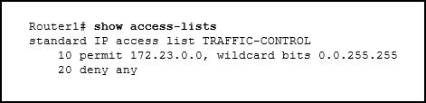
A network administrator needs to add an ACE to the TRAFFIC-CONTROL ACL that will deny IP traffic from the subnet 172.23.16.0/20. Which ACE will meet this requirement?
  - 15 deny 172.23.16.0 0.0.15.255
  - 5 deny 172.23.16.0 0.0.15.255
  - 30 deny 172.23.16.0 0.0.15.255
  - 5 deny 172.26.16.0 0.0.255.255

- Which ACE would permit traffic from hosts only on the 192.168.8.0/22 subnet?
  - permit 192.168.8.0 0.0.7.255
  - permit 192.168.0.0 0.0.15.255
  - permit 192.168.8.0 0.0.3.255
  - permit 192.168.8.0 255.255.248.0

- What is defined by the ip nat pool command when configuring dynamic NAT?
  - the pool of global addresses
  - the range of internal IP addresses that are translated
  - the pool of available NAT servers
  - the range of external IP addresses that internal hosts are permitted to access

- Refer to the exhibit.
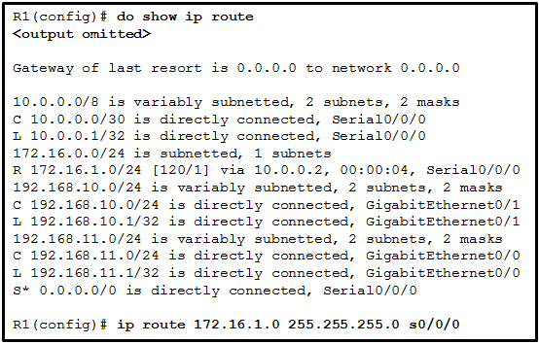
What would happen after the IT administrator enters the new static route?
  - The 172.16.1.0 route learned from RIP would be replaced with the 172.16.1.0 static route.
  - The 172.16.1.0 static route would be entered into the running-config but not shown in the routing table.
  - The 0.0.0.0 default route would be replaced with the 172.16.1.0 static route
  - The 172.16.1.0 static route is added to the existing routes in the routing table
- Refer to the exhibit.
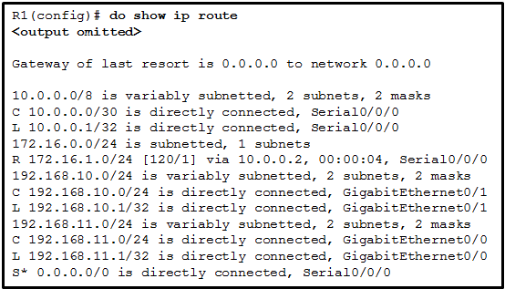
Which static route would an IT technician enter to create a backup route to the 172.16.1.0 network that is only used if the primary RIP learned route fails?
  - ip route 172.16.1.0 255.255.255.0 s0/0/0 91
  - ip route 172.16.1.0 255.255.255.0 s0/0/0
  - ip route 172.16.1.0 255.255.255.0 s0/0/0 111
  - ip route 172.16.1.0 255.255.255.0 s0/0/0 121
- Refer to the exhibit.
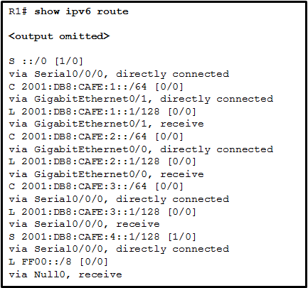
How was the host route 2001:DB8:CAFÉ:4::1/128 installed in the routing table?
  - The route was automatically installed when an IP address was configured on an active interface.
  - The route was dynamically learned from another router.
  - The route was manually entered by an administrator.
  - The route was dynamically created by router R1.

- What is the purpose of the overload keyword in the ip nat inside source list 1 pool NAT_POOL overload command?
  - It allows many inside hosts to share one or a few inside global addresses.
  - It allows a pool of inside global addresses to be used by internal hosts.
  - It allows external hosts to initiate sessions with internal hosts
  - It allows a list of internal hosts to communicate with a specific group of external hosts

- Which action should be taken when planning for redundancy on a hierarchical network design?
  - Immediately replace a nonfunctioning module, service, or device on a network
  - Purchase backup equipment for every network device at the distribution layer
  - Implement STP PortFast between the switches on the network
  - Add alternate physical paths for data to traverse the network

- What is the function of STP in a scalable network?
  - It decreases the size of the failure domain to contain the impact of failures
  - It protects the edge of the enterprise network from malicious activity
  - It disables redundant paths to eliminate Layer 2 loops.
  - It combines multiple switch trunk links to act as one logical link for increased bandwidth.

- What route would have the lowest administrative distance?
  - a directly connected network
  - a static route
  - a route received through the EIGRP routing protocol
  - a route received through the OSPF routing protocol

- Refer to the exhibit.
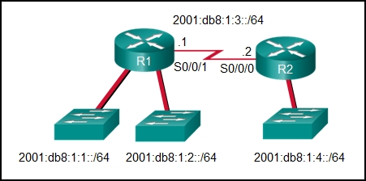
What command would be used to configure a static route on R1 so that traffic from both LANs can reach the 2001:db8:1:4::/64 remote network?
  - ipv6 route ::/0 serial0/0/0
  - ipv6 route 2001:db8:1:4::/64 2001:db8:1:3::1
  - ipv6 route 2001:db8:1:4::/64 2001:db8:1:3::2
  - ipv6 route 2001:db8:1::/65 2001:db8:1:3::1

- What is a characteristic of the distribution layer in the three hierarchical model?
  - acts as the backbone for the network, aggregating and distributing network traffic throughout the campus
  - provides access to the rest of the network through switching, routing, and network access policies
  - distributes access to end users
  - represents the network edge

- What routing table entry has a next hop address associated with a destination network?
  - directly-connected routes
  - local routes
  - remote routes
  - C and L source routes
- Which type of inter-VLAN communication design requires the configuration of multiple subinterfaces?
  - router-on-a-stick
  - routing via a multilayer switch
  - routing for the management VLAN
  - legacy inter-VLAN routing

- Refer to the exhibit.
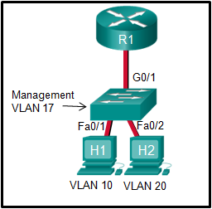
In what switch mode should port G0/1 be assigned if Cisco best practices are being used?
  - access
  - trunk
  - native
  - auto

- Why does a Layer 3 device perform the ANDing process on a destination IP address and subnet mask?
  - to identify the broadcast address of the destination network
  - to identify the host address of the destination host
  - to identify faulty frames
  - to identify the network address of the destination network

- A router is configured to participate in multiple routing protocol: RIP, EIGRP, and OSPF. The router must send a packet to network 192.168.14.0. Which route will be used to forward the traffic?
  - a 192.168.14.0/26 route that is learned via RIP
  - a 192.168.14.0/24 route that is learned via EIGRP
  - a 192.168.14.0/25 route that is learned via OSPF
  - a 192.168.14.0/25 route that is learned via RIP

- An organization is assigned an Ipv6 address block of 2001:db8:0:ca00::/56. How many subnets can be created without using bits in the interface ID space?
  - 256
  - 512
  - 1024
  - 4096

- As the network administrator, you have been asked to implement EtherChannel on the corporate network. What does this configuration consist of?
  - providing redundant links that dynamically block or forward traffic
  - grouping multiple physical ports to increase bandwidth between two switches
  - grouping two devices to share a virtual IP address
  - providing redundant devices to allow traffic to flow in the event of device failure

- Which characteristic would most influence a network design engineer to select a multilayer switch over a Layer 2 switch?
  - ability to build a routing table
  - ability to aggregate multiple ports for maximum data throughput
  - ability to provide power to directly-attached devices and the switch itself
  - ability to have multiple forwarding paths through the switched network based on VLAN number(s)

- A network administrator is planning to add a new switch to the network. What should the network administrator do to ensure the new switch exchanges VTP information with the other switches in the VTP domain?
  - Configure the correct VTP domain name and password on the new switch
  - Associate all ports of the new switch to a VLAN that is not VLAN 1.
  - Configure the VLANs on the new switch.
  - Configure all ports on the new switch to access mode.

- Refer to the exhibit.
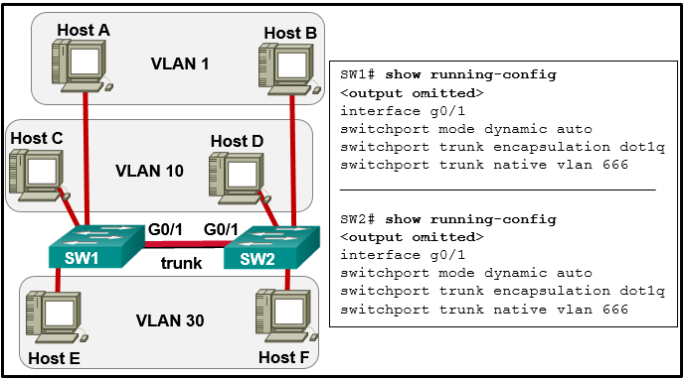
The network administrator configures both switches as displayed. However, host C is unable to ping host D and host E is unable to ping host F. What action should the administrator take to enable this communication?
  - Include a router in the topology
  - Associate hosts A and B with VLAN 10 instead of VLAN 1
  - Remove the native VLAN from the trunk
  - Configure either trunk port in the dynamic desirable mode

- What eliminates switching loops?
  - hold-down timers
  - poison reverse
  - Spanning Tree Protocol
  - Time to Live

- Refer to the exhibit.
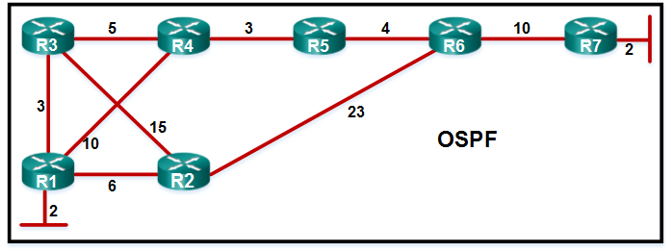
A network administrator has configure OSPF in the topology as shown. What is the preferred path to get from the LAN network that is connected to R1 to the LAN network that is connected to R7?
  - R1-R3-R4-R5-R6-R7
  - R1-R3-R2-R6-R7
  - R1-R2-R6-R7
  - R1-R4-R5-R6-R7

